## Todo: to record all of the following “transcripts”

# Urban issues

# Part 1) Talk about your city (a typical LETLS topic)

## 1st row

## Lexical resource

|  |
| --- |
| ##〔疾病或问题〕地方性的； (不好的情况、不好的社会问题)总是存在于某个地方/在某个地方极为普遍的常有的 endemic  1. ADJ If you say that a condition or problem esp bad or unpleasant is endemic, you mean that it is very common and strong, and cannot be dealt with easily；an endemic disease or problem is always present in a particular place, or among a particular group of people  e.g. Violent crime is now *endemic* in parts of Chicago. 芝加哥一些地区暴力犯罪成患,""极为普遍""  e.g. Discrimination against Catholics is *endemic* in Northern Ireland's institutions. 对天主教徒的歧视在北爱尔兰的公共机构中"极为普遍""  e.g. Bribery, corruption, and **embezzlement** are very **endemic** in CHINA, esp in small cities. //**embezzle /ɪmˈbɛzəl/** V-T If someone embezzles money that their organization or company has placed in their care, they take it and use it illegally for their own purposes. 挪用 (钱款)  e.g. **\*\*Pickpocketing扒窃 and purse snatching\*\*** are \***endemic**\* in the LA downtown area and even \*\***rampant**猖獗** in recent years . 闹市区扒窃活动猖獗 //if you describe something bad, such as a crime or disease, as **rampant**, you mean that it is very common and is increasing in an uncontrolled way.〔犯罪、疾病等〕猖獗的，泛滥的，失控的  2. ADJ If a disease or illness is endemic in a place, it is frequently found among the people who live there. (疾病)在某个地方是很常见的  • Polio was then *endemic* among children my age. 小儿麻痹症在当时是在我这个年纪的儿童中常见的疾病。 |

* disband /dɪsˈbænd/ n) [disbandment](javascript:void(0);) 解散遣散(一个小组，一个团体; 军队)   
   **[ disband a group; disband an army ]** 1.V-T/V-I If someone disbands a group of people, or if the group disbands, it stops operating as a single unit. e.g. We agreed to disband this “patent brainstorm” group.   
  E.g. All the armed groups will be **disbanded**. 所有武装团体将被解散。  
  E.g. But Rumsfeld says he has no regrets about the decision to go to war in Iraq, and does not regret later decisions to **disband the Iraqi army**.  解散军队
* barber 理发师; barber shop 理发店; hairdresser美发师/理发师; 理发店

1. A hairdresser is a person who cuts, colours, dyes, or arranges people's hair. 美发师/理发师 = barber

2. A **hairdresser** or a **hairdresser's** is a place where a hairdresser/barber works = barber shop 理发店 e.g. I work in this new **hairdresser's/barber shop**. 我在这个新开的理发店工作

* Fukuoka 福冈 ['fu:ku:'əuka];
* Olso  n. 奥斯陆（挪威首都）
* take sth into account = consider sth: There are so many things that we’ve got to **take into account** before deciding on our perfect place to **dwell in/live**, to choose a more **inhabitable/liveable适宜居住的** city.
* (酒店的/小区的便利) 设施 amenity, amenities /əˈmiːnɪtɪ/ [ə'**mɛ**nəti] Amenities are things such as shopping centres or sports facilities (e.g. gyms, swimming pools) that are provided for people's convenience, enjoyment, or comfort. **[ hotel amenities e.g. SPA, meeting room, gym] [ local amenities, e.g. parks, swimming pool or library in a community]**e.g. The **hotel amenities** include health clubs, conference facilities, and **banqueting rooms**. 这家旅馆的**设施**包括健身俱乐部和**宴会厅** //**boutique hotel/shoe stores**; a **bouquet/nosegay** of flowers
* inhabit /ɪnˈhæbɪt/

1. **[ sb. inhabit somewhere = dwel[l i]n somewhere]**If a place or region is inhabited by a group of people or a species of animal, those people or animals live there. 居住于 somewhere e.g. The valley **is inhabited by** the Dani tribe. 这个山谷里居住着丹尼部落 e.g. The valley **is inhabited by** the Dani tribe. 这个山谷里居住着丹尼部落。 ...the people who **inhabit/dwell in these islands.** …居住于这些岛屿的人们  
  
2. N) **居民；居住者 inhabitant [in'hæbitənt]/dweller** a person who inhabits a particular place

2. inhabitable= liveable [ɪn'hæbɪtəbl] adj. 适于居住的 **[ an inhabitable city; a liveable city ]** e.g. Singapore is rated as the most **inhabitable/liveable city** in the world.

* N/v 低语/窃窃私语; 低声抱怨；(河水)潺潺声; (远处谈话等)轻微连续的低声 murmur   ['mɜːmə]    //nag: 唠叨

1.V-T If you **[murmur something] or [murmur sth to sb]**, you say it **very quietly**, so that not many people can hear what you are saying. 小声说 ; N) They spoke **in low murmurs**. E.g. He turned and **murmured something to** the professor. 小声/窃窃私语对教授说了些什么. E.g. “How lovely," she murmured. 她低声说。

2. V/N 低声抱怨 a complaint uttered in a low and indistinct tone.   
=> 毫无怨言的做xxx If someone **[ does something without a murmur ]**, they do it without complaining. e.g. Then came the bill and my friend paid up **without a murmur**. 我朋友**毫无怨言地**结了帐

3.N A murmur is a continuous low sound, like the noise of a river or of voices far away. (河水)潺潺声; 远处谈话等轻微连续的低声 e.g. The piano music mixes with the murmur of conversation. 钢琴音乐与轻轻的谈话声混合在一起。 E.g. Listen to the vivid **murmur of the river** (河水)潺潺声

4.N A murmur is an abnormal sound which is made by the heart and which shows that there is probably something wrong with it. **(心脏发出的) 杂音 [ a heart murmur ]**  e.g. The doctor said James had now developed **a heart murmur**. 医生说詹姆斯 **心脏现在出现了杂音**。

* burgeon /ˈbɜːdʒən/  => burgeoning ['bə:dʒəniŋ] adj. 增长/发展迅速的；生机勃勃的 [ a burgeoning market ]

n. 萌芽嫩枝 See the **vivid/vibrant green鲜绿** **burgeon** of that **pot plant** 看那个**盆栽**的鲜绿的**萌芽**  
vi. Literal meaning: (plant, tree) 发芽; figurative meaning: (像萌芽一样) **迅速**生长/发展 If sth **burgeons**, it grows, flourishes, or develops **rapidly**. (像萌芽一样) **迅速**生长/发展   
e.g. Plants **burgeon** from every available space. 植物能从任何可获得的空间中**发芽,迅速生长**。  
E.g. My confidence began to **burgeon** later in life. 我的信心到了晚年开始 **迅速增长**

e.g. The **brain-drain effect 人才外流现象**of studying abroad has started to **burgeon** due to flaws in the domestic academic environment. Last year, more than ten thousands of **high-caliber['haikælibə] IT engineers** have applied for emigration.  **人才外流的现象** 已经(像萌芽一样) **迅速**生长/发展   
E.g. The seed of friendship and cooperation that **we sow 播种[səu]** today will burgeon, blossom, and harvest in the future and China-US partnership of cooperation will definitely enjoy a better tomorrow 我们播下的友好合作种子一定能够(像萌芽一样) **迅速**生长/发展、开花, 结果

* **boutique** /buːˈ**tiːk**/ A boutique is a small shop that sells fashionable clothes, shoes, or jewellery. 时尚精品小店 **[** [**boutique hotel**](javascript:void(0);)**精品酒店; boutique coffee house; boutique shoe shops ]**

V.S.

**宴会 banquet ['bæŋkwit]** a ceremonial dinner party for many people **[banquet room宴会厅]**

V.S.

**bouquet** /bəʊˈ**keɪ,** buː-/ **A bouquet/nosegay is** a bunch of flowers which is attractively arranged. 花束 E.G. The woman carried **a bouquet/nosegay of** dried violets. 一束干紫罗兰花

* **人才外流的现象[ the brain-drain effect ]**e.g. The **brain-drain effect 人才外流**of studying abroad has started to **burgeon** due to flaws in the domestic academic environment.  Last year, more than ten thousand of **high-caliber['haikælibə] IT engineers** have applied for emigration. **人才外流的现象** 已经(像萌芽一样) **迅速**生长/发展。
* Be **commended**/praised for sth e.g. Seoul, the capital of South Korea, **is commended for** is top air quality, weather condition, highly developed transportation system.
* 厌烦了xxx: be sick of/ tired of/w**ea**ry ['w**iə**ri] of/ get fe**[d u]**p with sth
* w**ea**ry ['w**iə**ri] V.S. w**a**ry /ˈw**ɛə**rɪ/(cautious, prudent)
* 高水平的；高质量的(员工，学生； 学校) **[ high-caliber students/employees; high-caliber university ['haikælibə] ]**  
  e.g. The **brain-drain effect 人才外流**of studying abroad has started to **burgeon** due to flaws in the domestic academic environment. Last year, more than ten thousands of **high-caliber['haikælibə]** IT engineers have applied for emigration. 出国留学造成 **人才外流的现象** 已经初显萌芽/. (像萌芽一样) **迅速**生长/发展。
* 迄今为止 It is **by far** the largest city in my country.  
  e.g. It’s **by far** the most delicious cuisine I’ve ever had in CHINA.
* **无疑的，肯定的 undoubtedly (without doubt)/easily/way/unquestionably[ʌn'kwɛstʃənəbli]**

e.g. The train is **without doubt/undoubtedly** **by far** the fastest way to go.  
e.g. You are **without doubt/undoubtedly** the nicest boyfriend I’ve ever met.

e.g Downtown is **easily** a great place to live in the city.  
e.g. That’s **definitely** not a big problem, OK?

e.g There are **unquestionably** [ʌn'kwɛs**tʃə**nəbli] **[prəuz] and cons/kɒn/** to living in a city. //con = drawbacks/downsides

e.g It’s **way** overpriced.

* con /k**ɒ**n/

1.V  If someone cons you, they persuade you to do something or believe something by telling you things that are not true. **哄骗 [ 骗了sb什么东西(钱财) con sb. of sth; con sb. to do sth ]** e.g. He **claimed** that the businessman had **conned him of** $10,000. 他**声称**那个商人骗了他1万美元。

2.N **骗局 [ a con = a fraudulent, deceptive trick] A con is a fraudulent, deceptive trick** in which someone deceives you by telling you something that is not true. e.g. Snacks that offer miraculous weight loss are **a con**. 神速减肥的快餐食品是个**骗局**。

3.N an argument or vote against a proposal, motion, etc 反对的理由; 反对的投票

4. **pros [prəuz] and cons/kɒn/**   = advantages/benefits and **drawbacks/downsides**

* **[ concrete jungle = the city jungle ]**

e.g. SH, **undoubtedly/unquestionably**, is the **1st tier city** in CHINA, however is just **a concrete/city jungle** from my point of view/perspective, **likewise类似的**, Seoul in South Korea or Tokyo in Japan. You’ve got to see the modern skyscrapers, boutique hotels, and **exotic [,iɡ'zɔtik] 洋派的**coffee houses. However, if you wanna taste the history of CHINA, SH is not a good choice, but Xi’an.

* cozy /ˈkəʊzɪ/ e.g. Even though the room is so **stuffy闷热的**, the bed is very **cozy/comfortable**.
* sprawl /sprɔːl/  **[ a sprawling city: 一个无计划，胡乱扩张的城市; the urban sprawl 城市扩张；都市向郊区扩张的现象; spraw[l out] on the bed. = spraw[l o]n the bed 摊开四肢躺在床上; spraw[l o]ut on the couch = spraw[l o]n the couch; sprawl out in the sofa ]**   
  1.V-I If you sprawl somewhere (in the bed or sofa), you sit or lie down with your legs and arms spread out in a careless **casual** way. 伸开四肢坐着; 摊开四肢躺着 e.g. She sprawled on the bed as he had left her, not even moving to cover herself up. 她摊开四肢躺在床上，甚至懒得动动把自己盖上。

2.[ Sprawl out ] 伸开四肢坐着; 摊开四肢躺着 e.g. He would take two aspirin and sprawl out on his bed.摊开四肢躺在床上。

3.V-I If you say that a place **sprawls**, you mean that it covers a large area of land. (地区，城市的)延伸 **[ a sprawling city: 一个无计划，胡乱扩张的城市]** e.g. The State Recreation Area sprawls over 900 acres on the southern tip of Key Biscayne. 休闲区占地九百多英亩，地处基·比斯坎南端。 e.g. **Firecrackers** and fireworks are just one **contributing factor** to pollution in Xi’an, which lacks an effective public transportation system. The **sprawling city 一个胡乱扩张的城市** has 9 million vehicles, and new **license plate numbers 车牌号**are being registered at a rate of 1,400 per day. Consumption of **fossil fuels**, like coal and natural gas, that are **non-renewable energies**, “contribute” a lot to **carbon footprint** that is the main reason to our climate change and air pollution. Additionally, construction dusts add poisonous particles and toxic gasses to the mix. The Friday's ruling is not the first time the court has enforced action on pollution. In 2015, the court **levied a new tax on征兵，征税** commercial trucks entering the city -- a **draconian** (harsh and severe) measure that environmentalists viewed as a positive.

4.N)  You can use sprawl to refer to an area where a city has grown outward in an **uncontrolled** way. (城市的) 无计划扩张区域 **[**[**urban sprawl**](javascript:void(0);)**城市扩张；都市向郊区扩张的现象 ]**  e.g. The whole **urban sprawl** of Xi’an/SH contains over 2.6 million people. 整个**城市扩张**总共容纳了260万以上的人口。

## Adjective for “big” V.S. “small”

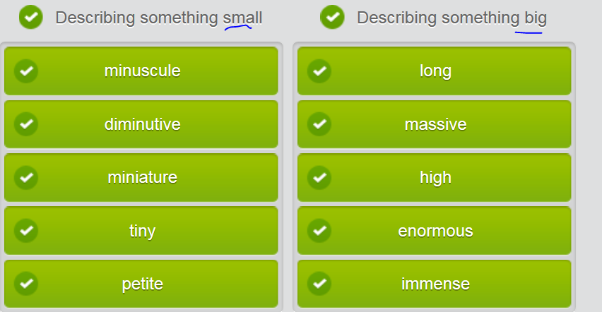

* petite /pəˈtiːt/  **[ petite and slender 娇小且苗条; a petite lady ]**   
  If you describe a woman as petite, you are politely saying that she is small, a little short, and is not fat. 娇小的 e.g. Even though I’m of below average height, **I’m petite and slender**. 低于平均身高，娇小且苗条

e.g. Even though LiuJuan has delivered two babies, she’s still **petite and slender**.

* minute adj) /**maɪˈnjuːt**/ => **minu**scule **[**'mi**nəs**kju:l, mi'nʌs-]  
  1. If you say that something is minute  /**maɪˈnjuːt**/ , you mean that it is very small. (space, room )非常小的 e.g. Even though this room is **minute**, it’s very **cozy**/**comfortable**. E.g. Only a minute amount is needed. 只需很少的一点。

**2.ADJ precise or detailed 精确的; 详细的 e.g. a minute examination**

* **minuscule [**'mi**nəs**kju:l, mi'nʌs-] **V.S. masculine image ['mæskjulin]男子阳刚**n.) the characters that were once kept in bottom half of a compositor's type case, [lower-case letter](javascript:void(0);) e.g. Tracy’s poetry is written all in minuscule letters   
  Adj) very small, **minuscule = tiny = diminutive**
* **di’minutive /dɪˈmɪnjʊtɪv/ = tiny, minuscule /'minəskju:l/**A diminutive person or object is very small. 微小的 e.g Her eyes scanned the room until they came to rest on **a diminutive figure** standing at the entrance.一个的小小的身影
* **mini + creature** ['k**riː**tʃə] **=> miniature**/ˈmɪnɪtʃə/1.ADJ 微型/袖珍的 Miniature is used to describe something t**hat is very small/tiny/minuscule/'minəskju:l/**/**diminutive/dɪˈmɪnjʊtɪv/**, especially a smaller version of something which is normally much bigger. **[ miniature book 袖珍的书; miniature toy; miniature camera** [摄] 小型照像机 **]** e.g. Rosehill Farm has been selling miniature roses since 1979. 玫瑰山农场就一直出售袖珍玫瑰。

2. If you describe one thing as another thing **[in miniature ],** you mean that it is much smaller in size or scale than the other thing, but is otherwise exactly the same. （xxx的）缩影 e.g. Ecuador provides a perfect introduction to South America; it's a continent **in miniature**. 它是整个大陆**的缩影**。  
3.N) **A miniature is a very small, detailed painting, often of a person portrait. 袖珍画像/**肖像

* **enormous** mountain V.S. **immense** pleasure
* **gigantic**/dʒ**aɪ**ˈɡæntɪk/

If you describe something as gigantic, you are emphasizing that it is extremely large in size, amount, or degree. 巨大的 e.g. In Red Rock Valley the road is bordered by gigantic /dʒ**aɪ**ˈɡæntɪk/rocks. 巨大的岩石

## Done mp3) video

## 2nd row) Modifier

|  |
| --- |
| **Modifiers** are words, phrases or clauses从句 that add detail, complements, or description to a sentence. In these examples, the **modifiers** add force to the statement.   * 到目前为止；（与比较级或最高级连用）It is **by far** the largest city in my country. * **无疑地/肯定的: easily/without doubt/undoubtedly = definitely= unquestionably = way**   e.g. The train is **easily/without doubt/undoubtedly** the fastest way to go.  e.g. Tokyo is **easily/undoubtedly/without doubt** one of the most expensive cities in the world, space **at a premium** 空间非常珍贵  e.g. Yeah, but Hawaii is also **easily/undoubtedly/without doubt** one of the most expensive places to live. I think everything there is **way/undoubtedly** overpriced.  e.g. Downtown is **definitely** a great place to live in the city.  e.g There are **unquestionably** [ʌn'kwɛst**ʃə**nəbli] **[prəuz] and cons/kɒn/**   to living in a city.   **//con/kɒn/ sb. to do欺诈 //pros and cons = advantages and drawbacks/downside** Dangling modifier/misplaced modifier e.g. I love reading futuristic novels/science fictions **that is written by Jill** |

## Done mp3) video



## 3rd row) Considering benefits and drawbacks of moving to another city

## “Deciding factor” of moving to another city that you think is more inhabitable/liveable

To “talk about/promote your city” or to talk about your “quality of life”, can take the following “deciding factors” into account. **(a typical IELTS oral topic) – Seoul, why that city is more inhabitable or liveable.**

* Cost of living: rent/monthly mortgage, facility fee, natural gas, internet fee, transportation fee
* Medical system, quality of local school
* Business and working opportunities
* Air quality, weather condition
* Transportation system
* City safety (crime, petty crimes, e.g. shoplifting在商店偷窃 or felony, e.g. arson)

petty crimes V.S. felony V.S. a hanging offence滔天大罪

|  |  |
| --- | --- |
| Petty crimes (minor) | Shoplifting, burglary  e.g.  e.g. **\*\*Pickpocketing扒窃 and purse snatching\*\*** are \***endemic**\* in the LA downtown area and even \*\***rampant**猖獗** in recent years . 闹市区扒窃活动猖獗 //if you describe something bad, such as a crime or disease, as **rampant**, you mean that it is very common and is increasing in an uncontrolled way.〔犯罪、疾病等〕猖獗的，泛滥的，失控的 |
| Felony | Drug trafficking, human trafficking |
| Hanging offence滔天大罪 | 'It was almost a hanging offense.' means the following  e.g. Once, pretty much everywhere, beating your wife and children was regarded as a father's duty, homosexuality was **a hanging offense**, and waterboarding was approved.  以前，几乎在任何地方，打老婆打孩子都是天经地义之事，同性恋也是 滔天大罪，而水刑也不会招致异议 |

* for fun, entertaining activities, e.g. free gallery exhibition; concert; carnival; bar and coffee houses, e.g. art and architecture

## Done mp3) Video) The “deciding factors” for choosing another city to live



























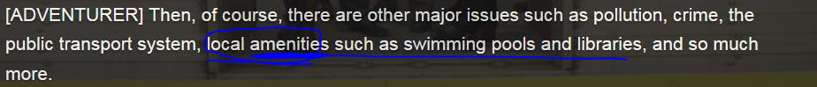













Fukuoka 福冈 ['fu:ku:'əukə]; If sth burgeons, it grows, flourishes, or develops very quickly 像萌芽一样**迅速**发展/生长



## Done mp3) Video



## Moving to a big city from rural

SARAH: **I'm tired of/sick of/getting fed up with** living in this tiny village. I want to move to an exciting big city.  
  
PAUL: Ah, bright lights, big city...  
  
SARAH: Yeah, I **feel dead** here. This must be **unquestionably** the most boring place on earth. **It’s boring to death.**  
PAUL: So, where would you like to live then?  
  
SARAH: I've done some research - maybe in Honolulu on Hawaii. **Apparently** they have **by far** the best weather there.  
  
PAUL: Yeah, but Hawaii is also **easil无疑地/undoubtedly** one of the most expensive places to live. I think everything there is **way** overpriced.  
  
SARAH: That's ok. I can work and earn money - that's **definitely** not a problem.  
  
PAUL: Well, it looks like you've already made up your mind. Off you go then.  
  
SARAH: Oh, thank you Paul! You're **easily无疑地without doubt/undoubtedly** the nicest boyfriend. And, of course, I want you to come with me.

…

PAUL: So, you really want me to come to Hawaii with you?

SARAH: Yes, of course. Don't you want to? The weather there is great.

PAUL: Well, I was considering it but...

SARAH: But?

PAUL: It seems to be a great place for vacations. But one **drawback/downside/disadvantage** is that there's not much work for me there. 不好的，缺点

SARAH: But Paul, you're a **hairdresser/barber**, you can find work anywhere.

PAUL: Hmm, perhaps. But what about **skiing**, you know how much I love skiing. One **disadvantage/drawback/downside** of living on Hawaii is there's no snow.

SARAH: Hah, you're wrong. You can ski on Mauna Kea mountain on the Big Island.

PAUL: Oh, really? Well, **on the one hand** I'd like to, but **on the other hand** ...

SARAH: Oh Paul, I think you're just looking for excuses because you don't want to live too far away from your mother.

## 4th row) Talk about your city

You're talking with a friend about the cities you live in. If you don't live in a city, talk about the city nearest you. You can talk about or describe a city per the following “deciding factors”; and the **[prəuz] and cons/kɒn/** of the city (by e.g. comparison between XI’na and SH) .

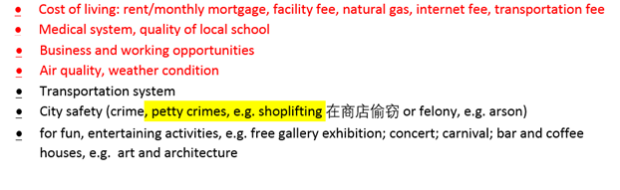

## Done mp3) Video

# Part 2) Choose another city to live

## 1st row) Types of settlement:

* cos’mopolis /kɒzˈmɒpəlɪs/ an international city 国际化都市 => cosmo’politan ['kɑzmə'pɑlətn]  , e.g. Seoul, SH, LA, Tykto
* me’tropolis  [mə'trɑpəlɪs] A metropolis is the largest, busiest, and most important city in a country or region. 大都会; Metropolis is an urban settlement which has at least half a million **inhabitants/dweller居民；居住者**. e.g. New Orleans is the metropolis of the American South. 新奥尔良是美国南部的大都会。
* City: e.g. Xi’an
* Town: e.g. YuHuaZhai town
* Village ( a permanent settlement that is bigger than a hamlet but smaller than a town)
* Hamlet: ( A hamlet is a very small village. 小村庄)
* Outskirts of the city or suburb
* Shantytown or slums贫民区: is a settlement of impoverished people living in improvised dwellings.
* dwelling ['dwɛlɪŋ]: (个人的)住宅,住处；寓所
* shack: A shack is a simple hut built from tin, wood, or other materials. 简易的棚屋

## Stop) Lexical resource

* 人才外流 e.g. The **brain-drain effect 人才外流**of studying abroad has started to **burgeon** due to flaws in the domestic academic environment.  出国留学造成 **人才外流的现象** 已经初显萌芽/. (像萌芽一样) **迅速**生长/发展。
* babble /ˈbæbəl/    
   1.V-I If someone babbles, they talk in a confused or excited way. 含糊不清地说; 兴奋地说

例：Similar to us, birds learn to sing by mimicking the adults, and the early chirps are akinto a baby's babble.  [跟读](javascript:;)

和人类一样，鸟类通过模仿长者学习鸣叫，最开始鸣叫时类似于婴儿的牙牙学语

They all babbled simultaneously.

他们全都异口同声地唧唧喳喳起来。 E.g. There's lots of confusion on all sides about what is "truth". However, this is just babbling out-of-context in this issue.

2.N-SING You can refer to people's voices as a babble of sound when they are excited and confused, preventing you from understanding what they are saying. 嘈杂的说话声

例：

Kemp knocked loudly so as to be heard above the high babble of voices.

肯普大声地敲门，以压过唧唧喳喳的高声喧哗而让人听见

* like-minded

1.ADJ Like-minded people have similar opinions, ideas, attitudes, or interests. 想法相同的

例：

...the opportunity to mix with hundreds of like-minded people.

…与数百个志趣相投的人打交道的机会。

* multitude /ˈmʌltɪˌtjuːd/  CET6 TEM8

1.QUANT A multitude of things or people is a very large number of them. 大量

例：

There are a multitude of small, quiet roads to cycle along.

有多条可以骑自行车的僻静小路。

Addiction to drugs can bring a multitude of other problems.

毒瘾会带来其他许多问题。

2.PHRASE If you say that something covers or hides a multitude of sins, you mean that it hides something unattractive or does not reveal the true nature of something. (被掩盖的) 种种丑恶

3.N-COUNT You can refer to a very large number of people as a multitude. 一大群人

例：

...surrounded by a noisy multitude.

…被吵吵嚷嚷的一大群人围着。

4.N-COUNT-COLL You can refer to the great majority of people in a particular country or situation as the multitude or the multitudes. 大多数人

例：

The hideous truth was hidden from the multitude.

向大众隐瞒了丑恶的真相。

词组短语 同近义词

[a multitude of](javascript:void(0);)大批的，众多的

* vulnerable /ˈvʌlnərəbəl/  CET6 TEM4

1.ADJ Someone who is vulnerable is weak and without protection, with the result that they are easily hurt physically or emotionally. 易受伤害的

例：

Old people are particularly vulnerable members of our society.

老人是我们社会中特别容易受到伤害的成员。

2.N-VAR 脆弱 vulnerability

例：

David accepts his own vulnerability.

戴维承认自己的脆弱。

3.ADJ If a person, animal, or plant is vulnerable to a disease, they are more likely to get it than other people, animals, or plants. 容易患…病的 e.g. e.g. Lack of clean water and medical care leaves people vulnerable to disease.

例：

People with high blood pressure are especially vulnerable to diabetes.

血压高的人尤其容易患糖尿病。

4.N-UNCOUNT 患病的可能性 vulnerability

例：

Taking long-term courses of certain medicines may increase vulnerability to infection.

长期服用某些药物可能会增加受感染的几率。

5.ADJ Something that is vulnerable can be easily harmed or affected by something bad. 易受损害的

例：

Their tanks would be vulnerable to attack from the air.

他们的坦克将易受空袭。

6.N-UNCOUNT 易受攻击性 vulnerability

例：

...anxieties about the country's vulnerability to invasion.

…对国家易受侵略的忧虑。

同近义词 同根词

词根：vulnerably

adv.

[vulnerably](javascript:void(0);) 脆弱地；易受伤害地

n.

[vulnerability](javascript:void(0);) 易损性；弱点



* impoverish /ɪmˈpɒvərɪʃ/  CET6+ TEM8 (impoverishing,impoverished,impoverishes)

1.V-T Something that impoverishes a person or a country makes them poor. 使贫困

例：

We need to reduce the burden of taxes that impoverish the economy.

我们需要减少使经济贫困的租税负担。

2.ADJ 贫困的 impoverished

例：

The goal is to lure businesses into impoverished areas by offering them tax breaks.

目的是通过提供减税优惠把企业吸引到贫困地区。

3.V-T A person or thing that impoverishes something makes it worse in quality. 使质量下降

例：

A top dressing of fertilizer should be added to improve growth as mint impoverishes the soil quickly.

应施顶肥以促进生长，因为薄荷会使土壤迅速变得贫瘠。

同近义词 同根词

词根：impoverish

adj.

[impoverished](javascript:void(0);) 穷困的；用尽了的，无创造性的

n.

[impoverishment](javascript:void(0);) 贫穷；致使贫乏或贫瘠之事物

* **高端的 (产品或服务; 楼盘) upmarket /ˌʌpˈmɑːkɪt/  = up-scale = high-end** 1.ADJ Upmarket products or services are expensive, of good quality, and intended to appeal to people in a high social class. E.g. ...**upmarket** department stores such as Bloomingdale's and Saks Fifth Avenue. **高档**连锁百货商店。  
  2.ADV Upmarket is also an adverb. 向高档地 e.g. T-shirts, the epitome of American casualness, have moved upmarket. T恤，美国人的随意的标志，已提升至高档商品之列
* mundane **[mʌn'dein]** V.S. mortal   
  e.g.Not only the environmental but also the economic and social implications of such trends are enormous. Among the major challenges are the **mundane [mʌn'dein] 平凡的 features of daily living**: clean water and air, sanitary waste facilities, the cost of food, and the availability of shelter and transportation.   
  V.S. I’m just **a mortal person**一个俗人
* dwelll /dwɛl/  V)

1. dwel**[l i]**n/at somewhere = **inhabit** somewhere. 居住在
2. If you dwel**[l o]**n/upon something, especially something unpleasant, you think, speak, or write about it a lot or **for quite a long time, at length** 细想; 详述 e.g. "I'd rather not **dwel[l o]n** the past," he told me. “我宁愿不多想过去，”他告诉我

* dwell (v), dwelling(n) /ˈdwɛlɪŋ/, dweller = inhabitant 居民；居住者

1.N-COUNT A dwelling or a dwelling place is a place where someone lives. 住所; 居住地 e.g. Some 3,500 new dwellings are planned for the area. 大约三千五百套新住宅计划在这个地区新建 e .g. Shantytown or slum is a settlement of **impoverished**/poor people living in improvised **dwellings**.

* cos’mopolis /kɒzˈmɒpəlɪs/ an international city 国际化大都市 => cosmo’politan ['kɑzmə'pɑlətn]  , e.g. Seoul, SH, LA, Tokyo.

me’tropolis  [mə'trɑpəlɪs] A metropolis is the largest, busiest, and most important city in a country or region. 大都会; Metropolis is an urban settlement which has at least half a million **inhabitants/dweller居民；居住者**e.g. New Orleans is the metropolis of the American South。E.g. She moves to a metropolis and finds a group of like-minded 志同道合的 people who share her passions and interests.

后来她搬到大都市，发现了同她分享激情和兴趣的一群志同道合的人

* hamlet ( A hamlet is a very small village. 小村庄) V.S. village ( is a permanent settlement that is bigger than a hamlet but smaller than a town)
* within walking distance e.g. The famous Food Street is within 5-min **walking distance.**
* shipyard /ˈʃɪpˌjɑːd/  A shipyard is a place where ships are built and repaired. 造船厂; 修船厂 e.g. The Queen Mary 2 is currently docked at the shipyard. “玛丽女王２号”现在停泊在修船厂。
* 有轨电车(和地铁不一样)　 　tram **/træm/**  　 A **tram** is a public transportation vehicle, usually powered by electricity from wires above it, which travels along rails laid in the surface of a street**; tram is different from subway/tube** [[**peak tram**](javascript:void(0);)山顶电车; take a tram] e.g. How can I reach there? You can take a tram. E.g.You can get to the beach easily from the centre of town by tram. 坐有轨电车到达海滩。  
  2.N-COUNT A **tram** is the same as a . 缆车
* freeway /ˈfriːˌweɪ/

1.N-COUNT A freeway is a major road that has been specially built for fast travel over long distances. Freeways have several lanes and special places where traffic gets on and leaves. Another word for freeway is motorway. 高速公路 e.g. The speed limit on the freeway is 55mph. 这条高速公路的限速为每小时55英里。

shanty /ˈʃæntɪ/  shanty, shantytowns or slums

1.N-COUNT A shanty is a small rough hut which poor people live in, built from tin, cardboard, or other materials that are not very strong. (穷人居住的)简陋的小屋; 棚屋

2.N-COUNT A shanty is a song which sailors used to sing while they were doing work on a ship. 船夫曲; 船歌

shantytown /ˈʃæntɪˌtaʊn/

1.N-COUNT A shantytown is a collection of rough huts which poor people live in, usually in or near a large city. 以临时搭建的简陋房屋为主的城区

slum /slʌm/  CET6 TEM4

1.N-COUNT A slum is an area of a city where living conditions are very bad and where the houses are in bad condition. 贫民区

例：

...a slum area of St. Louis.

…圣路易斯的一个贫民区。

shack /ʃæk/  CET6+ TEM8 (shacking,shacked,shacks)

1.N-COUNT A shack is a simple hut built from tin, wood, or other materials. 简易的棚屋

2.V to evade (work or responsibility) (英格兰中部方言)逃避工作; 逃避责任

e.g 

evict /ɪˈvɪkt/  evict sb from somewhere, eviciton (evicting,evicted,evicts)

1.V-T If someone is evicted from the place where they are living, they are forced to leave it, usually because they have broken a law or contract. 驱逐/逐出sb e.g. They were evicted from their apartment after their mother became addicted to drugs. 他们就被逐出了他们的公寓。 E.g. In the first week, the city police evicted ten families per the so-called “dismantlement policy 房屋拆迁政策 ”. 在第1周里，该市警方驱逐了10户家庭。

endemic /ɛnˈdɛmɪk/ adj. 地方性的；风土的

n. 地方病

1.ADJ If a disease or illness is endemic in a place, it is frequently found among the people who live there. 常见的

例：

Polio was then endemic among children my age.

小儿麻痹症在当时是在我这个年纪的儿童中常见的疾病。

2. 1) endemic disease 地方性疾病; 2) If you say that a condition or problem is endemic in a place, you mean that it is very common and strong, existing in that place for a very long time, and cannot be dealt with easily. (情况、问题) 极为普遍的

例：

Discrimination against Catholics is endemic in Northern Ireland's institutions.

对天主教徒的歧视在北爱尔兰的公共机构中极为普遍。

pandemic /pænˈdɛmɪk/

1.N-COUNT A pandemic is an occurrence of a disease that affects many people over a very wide area. 流行病

例：

They feared a new cholera pandemic.

他们担心一种新的霍乱流行病。

## Done mp3) Living in shantytowns/slums



















*poverty: impoverishment





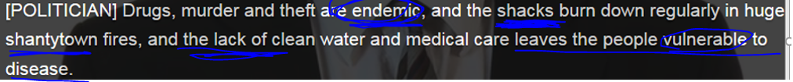

1) endemic disease 地方性疾病; 2) If you say that a condition or problem is endemic in a place, you mean that it is very common and strong, existing in that place for a very long time, and cannot be dealt with easily. (情况、问题) 极为普遍的









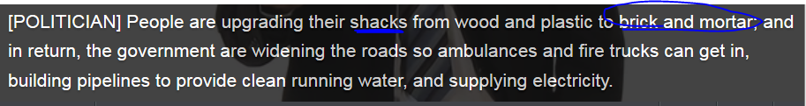





 evict sb: force sb to leave their place



## Done mp3) talking about the city of Oslo**['ɔzləu]** 奥斯陆(挪威首都)



* I’m going to Oslo next month, and I’m so excited (**intoxicated** = extremely excited; smashed/drunk)
* Yeah, you should be. It’s a great city. That’s where I’m from.
* I know. But there’s one thing that I’m a little confused. From the tour guide, Oslo is known for being a city with contrasts to **multitude**. It’s combination of natural beauty and modern facilities of a **metropolis /mə'trɑpəlɪs/** becomes the world’s biggest village. So is it a city, a metropolis [mə'trɑpəlɪs] 大都会, or a village?
* Hehe, it has to be everything. The center of Olso['ɔzləu] is a small compact, just like a village. Most hotels, meeting facilities, **local amenities [ə'mi:nəti, ə'men-],**  shopping malls, and entertainment areas are normally within **walking distance.**
* Wow, OK.
* On the other hand, the beautiful natural surroundings, diverse architecture, and multicultural **add** unique atmosphere in my city. You also find some modern districts such as XXX street, which is a transfer of **shipyards**造船厂; 修船厂, bars, restaurants, and cafes. I can tell you it’s an exciting and interesting neighbourhood.
* Wow, that sounds fantastic. Hmm, what about transport?
* You can **take the tram**有轨电车. There’re six lines here. Even take you out of here to the subsub/outskirts.
* Great. I cannot wait to go.
* I’m sure you’ll have lots of fun.

## 2nd row) **Reading skill**

|  |
| --- |
| **Reading skill – read for the main idea** |
|  |
| **Finding the main idea** of a paragraph or text is an important reading skill. The main idea is the general idea, not the details. Once you know the main idea, it's easier to understand the rest of the text. |
|  |
| You can often find out the main idea by identifying the topic sentence.  The topic sentence states what the paragraph is about. The topic sentence usually appears at the beginning of a paragraph, but it can appear anywhere, such as the end of the sentence as a conclusion. |
|  |
| If you're not sure what the topic sentence is, you can work out the main idea of a text by summarizing it in your own words. Look for repeated words or ideas to help you do this. |
|  |
| Don't be too narrow or too broad in identifying the main idea. Even though a statement might be true, it might be too specific or too general to be the main idea. |

## Reading

Experts predict that soon more people will live in cities than in rural areas. This **demographic [,dɛmə'ɡræfɪk]目标人群 shift** can mostly be witnessed in Africa and Asia, largely in low-income settlements in developing countries. Predictions say that the populations of the 22 "megacities" will each exceed 10 million and in some cases grow to more than 20 million by 2015.

Not only the environmental but also the economic and social implications of such trends are enormous. Among the major challenges are the **mundane [mʌn'dein] 世俗的平凡的 features** of daily living: clean water and air, sanitary waste facilities, the cost of food, and the availability of shelter and transportation. //I’m just **a mortal person**一个俗人

But the news is not all bad. There are a lot of examples of cities, such as Karachi (Pakistan) or Bogotá (Colombia) with projects aimed at improving the lives of urban **dwellers/inhabitants** while reducing the environmental impact of concentrated/dense populations. These include urban farming plots, solar water heaters, economic cooperatives, improved sewer facilities, and upgraded transportation systems.

## 3rd row) Comparing and contrasting

For details, see Training & Education > use Venn diagram to compare two objects

Prepositions介词 for comparing

Specific prepositions are used with words and phrases to compare and contrast. Sometimes more than one preposition can be used with the same meaning. In the two sentences below, **compared to** and **compared with** are both correct and mean the same thing.

* How do you find urban living **compared** **to** life on the farm?
* How do you find urban living **compared** **with**  life on the farm?

The adjective **different** can be followed by the prepositions **from**, **than**, and **to** with roughly the same meaning. **Different from** is common in both British and American English. **Different than** is used mainly in American English. **Different to** is more often used in British English.

* Living in a city is very **different from** living in a village.
* Living in a city is very **different than** living in a village.
* Living in a city is very **different to** living in a village.

|  |  |
| --- | --- |
|  |  |
|  |  |

Study these other examples of prepositions介词used for comparing and contrasting:

* The two cities **are very similar to** one another.
* **In contrast to** Beijing, Hong Kong is located directly on the water.

(In **stark** contrast to sth 和xxx 有鲜明的对比)

* They chose to live in a town **instead of** a city.
* Los Angeles is not **as** enormous **as** Shanghai.

|  |  |
| --- | --- |
|  |  |
|  |  |

|  |  |
| --- | --- |
|  |  |

## Not done mp3) to compare: express similarity or difference.

**For details, see Training & Education unit > Venn diagram**



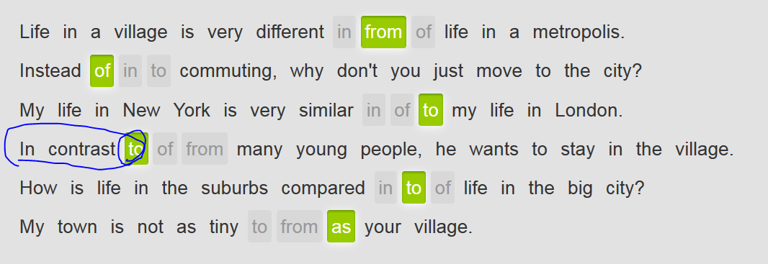

## 4th row) Choose a new city by taking about **quality of life**

Your friend wants to move with his wife and two small children from their village to a city. Job opportunities and schools are the most important **“deciding factors” to choose another city to live**. On weekends, the family would like to go to a green area for hiking and swimming.

|  |
| --- |
|  |
| https://cns2.ef-cdn.com/Juno/15/20/99/v/152099/GE_15.4.2.4.1_urban1.jpg | Greenwood is a lovely, medium-sized city. The **quality of life** here is excellent and **the cost of living** is very affordable. The economy hasn't done so well compared with the rest of the country and there is a lack of good jobs, but Greenwood does have a wonderful education system. In addition, Greenwood has **an abundance of** beautiful green spaces that are great for outdoor recreation. |
|  |  |
| https://cns2.ef-cdn.com/Juno/15/21/00/v/152100/GE_15.4.2.4.1_urban2.jpg | Compared to Greenwood, Centerville is a **metropolis [mi'trɔpəlis].** It isn't an enormous city, but it does have a very urban downtown. Many people like to live here because of its beautiful, traditional neighborhoods which make it feel similar to a big town rather than a huge city. It has a good education system and its economy has done so well compared with many other places that there is actually a bit of a labor **shortage**. The **cost of living** is very reasonable. |
|  |  |
| https://cns2.ef-cdn.com/Juno/15/21/01/v/152101/GE_15.4.2.4.1_urban3.jpg | Rotham is an immense city of many millions of people. It has some of the finest universities and probably best overall school system in the country. The economy has done well here, but there is intense competition for jobs because of the large numbers of people moving here. **The cost of living** is quite high. There is a lack of green spaces, but the city has so much else to offer. |

# Part 3) Promoting your city

## 1st row) Promote your city by taking the following “deciding factors” into account

To “talk about/promote your city” or to talk about your “quality of life”, can take the following “deciding factors” into account. **(a typical IELTS oral topic) – Seoul, why that city is more inhabitable or liveable.**

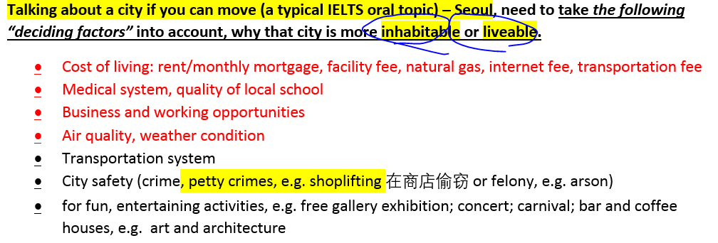

## Stop) Lexical resource

* Laos   [laʊz]   [laʊz]n. 老挝
* recline /rɪˈklaɪn/     
  1.V-I If you recline on something, you sit or lie on it with the upper part of your body supported at an angle. 斜靠 e.g. She proceeded to recline on a chaise longue. 她开始斜靠在一个躺椅上。  
  2.V-T/V-I When a seat reclines or when you recline it, you lower the back so that it is more comfortable to sit in. 使向后倾斜; 向后倾斜 e.g. Excuse me, (flight attendant FA), how do I **recline my seat** back a little bit? E.g. Air France first-class seats recline almost like beds. 头等舱座位的靠背可以向后倾斜得几乎像床一样。 E.g. He had reclined his seat and was lying back smoking. 拉米许已经把椅背向后调了
* **少数民族 [ethnic minority]**

e.g. One danger to **the ethnic minority**‘s way of life is the cutting down of trees. Another danger is rural migration to urban

* **splash /splæʃ/  CET4 TEM4 (splashing,splashed,splashes)**

1.V-I If you splash around or splash about in water, you hit or disturb the water in a noisy way, causing some of it to fly up into the air. 泼打戏水

例：

A lot of people were in the water, swimming or simply splashing about.

很多人在水里游泳或者只是戏水。

She could hear the voices of her friends as they splashed in a nearby rock pool.

她能听到她的朋友们在附近的岩石泳池里戏水的声音。

2.V-T/V-I If you splash a liquid somewhere or if it splashes, it hits someone or something and scatters in a lot of small drops. 使泼溅; 溅落

例：

He closed his eyes tight, and splashed the water on his face.

他紧紧地闭上眼睛，把水泼到脸上。

A little wave, the first of many, splashed in my face.

层层波浪中的第一层小浪溅在了我的脸上。

3.N-SING A splash is the sound made when something hits water or falls into it. 拍打水的声音; 落入水的声音 [ The Water Splash festival in Dai ethnic minority 傣族少数民族的 泼水节]

例：

There was a splash and something fell clumsily into the water.

扑通一声，什么东西重重地掉进了水里。

4.N-COUNT A splash of a liquid is a small quantity of it that falls on something or is added to something. (少量液体的) 溅落; (少量液体的) 添加

例：

Wallcoverings and floors should be able to withstand steam and splashes.

墙纸和地板应该能承受得住蒸汽和液体的泼溅。

5.N-COUNT A splash of colour is an area of a bright colour which contrasts strongly with the colours around it. (与周围颜色形成鲜明对比的) 亮色块

例：

...shady walks punctuated by splashes of colour.

…由鲜艳色彩点缀的条条林荫小径。

6.V-T If a magazine or newspaper splashes a story, it prints it in such a way that it is very noticeable. (报刊) 以显眼方式刊登

例：

The newspapers splashed the story all over their front pages.

各报都在头版全版以显眼的方式刊登了这个故事。

7.PHRASE If you make a splash, you become noticed or become popular because of something that you have done. 引起关注 [ media splash 媒体的轩然大波 ]

例：

Now she's made a splash in the television show "Civil Wars."

如今她因在电视节目《内战》中的出现而引起了人们的关注。

* **soak /səʊk/  CET4 TEM4 (soaking,soaked,soaks)**

1.V-T/V-I If you soak something or leave it to soak, you put it into a liquid and leave it there. 浸泡

例：

Soak the beans for 2 hours.

把豆子泡上两个小时。

2.V-T If a liquid soaks something or if you soak something with a liquid, the liquid makes the thing very wet. 使浸湿 I’m totally drenched 使湿透.

例：

The water had soaked his jacket and shirt.

水浸湿了他的夹克和衬衣。

3.V-I If a liquid soaks through something, it passes through it. 渗透

例：

There was so much blood it had soaked through my boxer shorts.

血出得太多，都渗透了我的平脚短裤。

4.V-I If someone soaks, they spend a long time in a hot bath, because they enjoy it. 长时间泡浴

例：

What I need is to soak in a hot tub.

我需要的是在浴盆里泡个热水澡。

5.N-COUNT Soak is also a noun. 泡浴

例：

I was having a long soak in the bath.

我当时正在浴室里长时间地泡浴。

* **indigenous /ɪnˈdɪdʒɪnəs/  本地人；土著；动植物的自生种；本地产的动植物**

1.ADJ Indigenous people or things belong to the country in which they are found, rather than coming there or being brought there from another country. 本土的; 当地的

例：

...the country's indigenous population.

…该国的本土人口。

* **原始森林virgin forest:** a forest in its natural state, before it has been **explored** 开发开采or exploited by man
* **monastery** /ˈmɒnəstrɪ/ A monastery is a building or collection of buildings in which **monks** live. 修道院
* **[美国英语]伐木工；樵夫 timberjack   ['timbədʒæk] V.S. lumber vt. 砍伐木材；n. 木材**
* compartment /kəmˈpɑːtmənt/  V.S. apartment V.S. department

1. A compartment is one of the separate parts of an object that is used for keeping things in. 隔间 e.g. Please put your luggage in your overhead **compartment** after your onboard. E.g. The fire started in the baggage **compartment**. 火是从行李舱着起来的。
2. A compartment is one of the separate spaces into which a railway carriage is divided. 火车车厢 e.g. On the way home we shared our first class **compartment** with a group of businessmen. 在回家的路上我们和一群商人共同乘坐头等车厢。

## done mp3) 56 tribes in CHINA





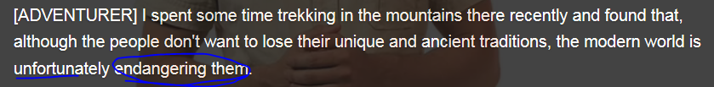

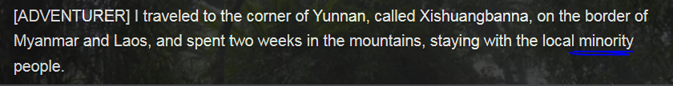















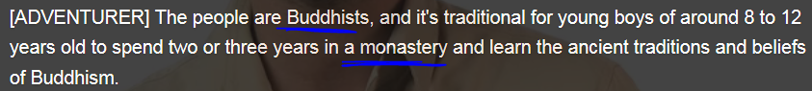











* Virgin forest: 原始森林; Timber, timberjack n. 伐木工







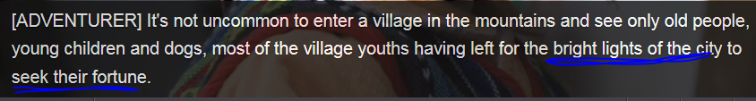









## Famous monuments in cities - natural and man-made tourist attractions

### Great Wall (China)

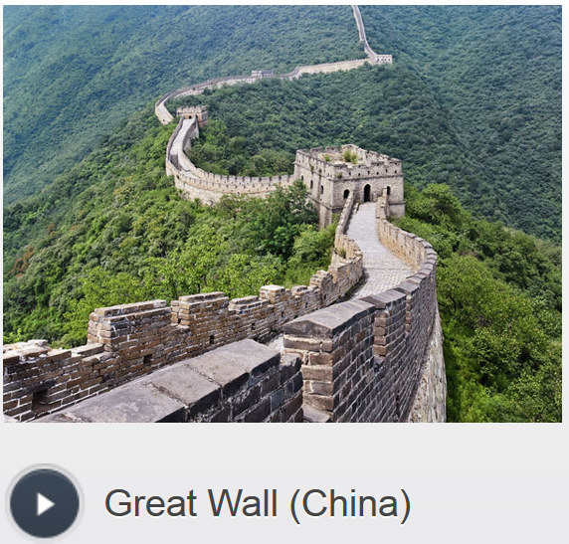 /ɡreɪt wɔːl/

a series of walls and guard towers made of stone, brick, tamped earth, wood, and other materials, built along an east-to-west line across the historical northern borders of China to protect the Chinese Empire in ancient times

1. The Great Wall near Beijing is a favorite tourist spot.
2. walking on the Great Wall

### Angkor Wat (Cambodia)

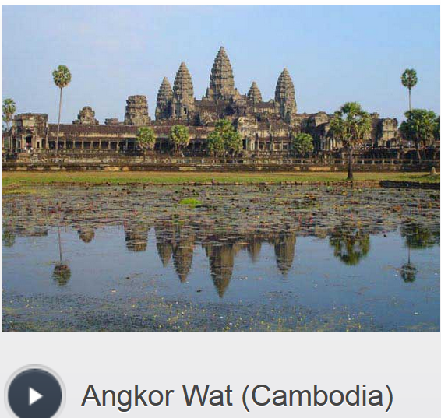 /ˈæŋkɔːr ˈwɒt/

a famous temple which is part of the archaeological remains of the different capitals of the Khmer Empire in Cambodia, from the 9th to the 15th century.

1. We spent the day visiting Angkor Wat.
2. feeling serene at Angkor Wat

### Macchu Picchu (Peru)

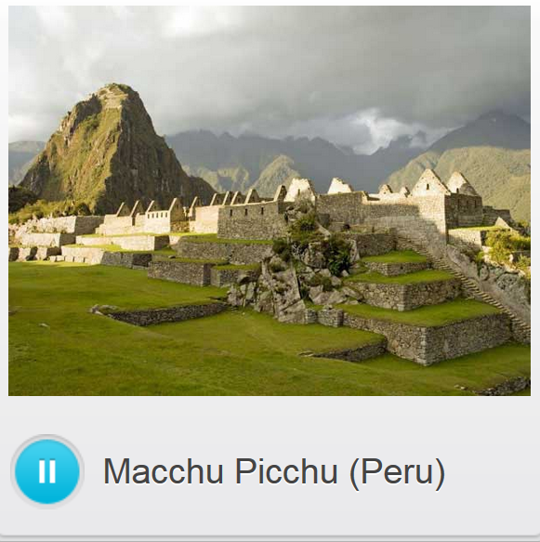 /mɑːˈtʃuː piːˈtʃuː/

The ancient Incan city in Peru, which is located at 7,000 feet above sea level in the Andean mountain range, is one of the world's best known archaeological sites.

1. Hiking up to Macchu Picchu was one the most exciting things I've done.
2. admiring the views at Macchu Picchu

### Reclining Buddha Temple (Thailand)

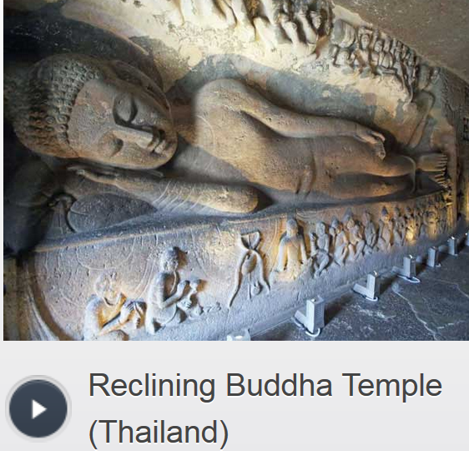

/rɪˈklaɪnɪŋ ˈbʊdə ˈtempl/

one of the oldest and largest temples in Bangkok with the largest statue of the reclining Buddha in Thailand

1. Our tour guide took us to see the Reclining Buddha Temple in Bangkok.
2. lighting incense at the Reclining Buddha Temple

### Brandenburg Gate (Berlin)

/ˈbrændənbərɡ ɡeɪt/

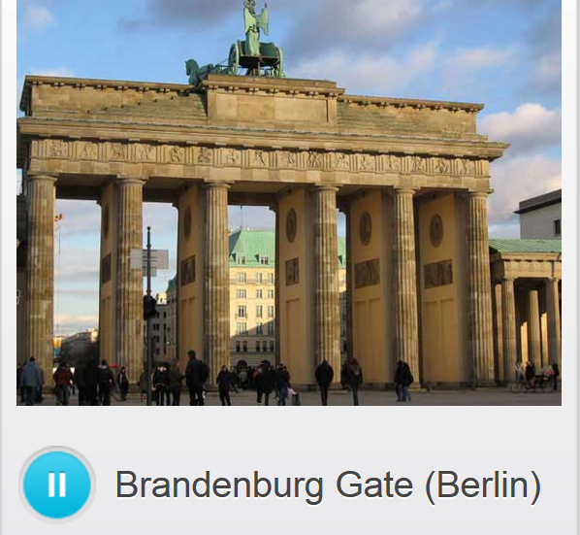

a former city gate, rebuilt in the late 18th century, which is now one of the most well-known landmarks of Germany.

1. The Brandenburg Gate is much larger in person than it looks in photos.
2. standing under the Brandenburg Gate

e.g 

### Taj Mahal (India)

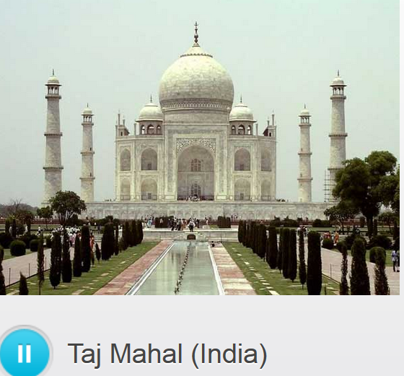 /ˈtɑːʒ məˈhɔːl/

a white marble mausoleum located in Agra, India, that was built under Mughal Emperor Shah Jahan in memory of his favorite wife, Mumtaz Mahal

1. I have always wanted to see the Taj Mahal.
2. touring the Taj Mahal

### City of Petra (Jordan)

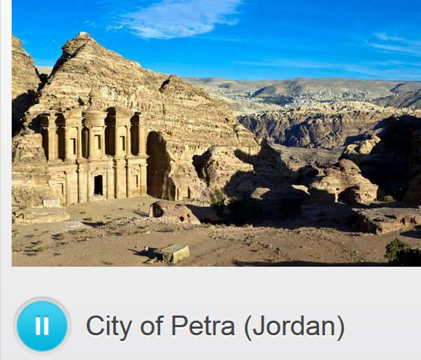 /ˈsɪti əv ˈpetrə/

a historical and archaeological city in southern Jordan that is famous for its rock-cut architecture

1. Some of the locals called the City of Petra the "rose city" because of the color of the stone.
2. standing beneath the entrance to the City of Petra

### Pyramids (Egypt)

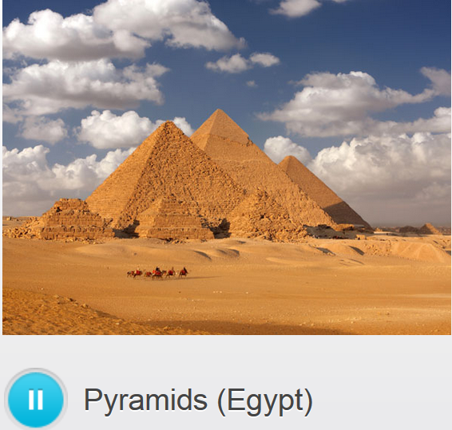/ˈpɪrəmɪ**dz**/

The ancient Egyptians built pyramids as tombs for the pharaohs and their queens, some of which are among the largest man-made constructions ever conceived.

1. We toured the famous Pyramids in Giza, Egypt.
2. riding camels to the Pyramids



## 2nd row) Relative clause 关系(定语)从句

In grammar, a relative clause is a subordinate clause which specifies or gives information about a person or thing. Relative clauses come after a noun or pronoun and, in English, often begin with a relative pronoun such as "who," "which," or "that." 关系从句

* **defining** relative clause 限定性-关系(定语)从句
* **non-defining** relative clause 非限定性 -关系(定语)从句

## **Defining** relative clauses限定性-关系(定语)从句

Some relative clauses provide **essential** additional information about someone or something. They identify which person or thing is referred to.

In the sentence below, the clause **that attracts more people than any other** tells you which monument the sentence is about. **If you remove the clause, the sentence CANNOT be understood.**  This is why these clauses are called **defining**. In these kinds of sentences, there is no comma before the clause.

e.g. It's the monument in Europe **that** attracts more people than any other

e.g. She's the woman **whom I met** in Shanghai last year

**Relative pronouns** 关系(定语)从句的限定代词**:**

* The **that** and **which** introduce relative clauses about things.
* The **relative pronouns** **where** specifically for places.
* The **relative pronouns** **who**, **whom**, **that** and **whose** introduce relative clauses about people.
* The **relative pronouns** **Whose** is used for possession.
* The **relative pronouns** **Whom** is used after **to** or **for**. **Whom** is also used when the pronoun refers to a noun that is the object of the clause.

## **Non-defining** relative clauses非限定性 -关系(定语)从句

**Non-defining relative clauses** provide **nonessential, additional** information about someone or something. **If you remove them from a sentence, the sentence still makes sense**.

e.g. The pyramids**, which were built thousands of years ago,** attract millions of tourists.

What's important to remember about these **nonessential** clauses is that they **always have commas**. When you say them, **you should pause slightly at the commas**. Note that all “relative pronouns” except **that** can be used in non-defining clauses.

## Reading

My friend **who** owns a restaurant in New York has invited us to visit him.

|  |
| --- |
|  |
| **Gabriela:** | Really? Sergio, **whom** I met last year, has invited us? |
| **Juan Manuel:** | No, it’s not Sergio. It’s Christian, my friend **whose** sister got married last year. |
| **Gabriela:** | Ah, that friend! Now I remember. |
| **Juan Manuel:** | I thought we could go in August, in the two weeks **which** you have to take off work anyway. |
| **Gabriela:** | Not a bad idea. I love big cities. And I’m dying to see New York. |
| **Juan Manuel:** | Great. Then we can go to the restaurant **that** Paul told us about. |
| **Gabriela:** | But I thought we were going to see Christian, **who** has a restaurant? |
| **Juan Manuel:** | Yes, we are, but we won’t be eating there all the time. |

## rd row) Describe and promote the city where you live

To “talk about/promote your city” or to talk about your “quality of life”, can take the following “deciding factors” into account. **(a typical IELTS oral topic) – Seoul, why that city is more inhabitable or liveable.**



## done mp3) Video: describe and promote your city



## 4th row)

You work in the business-investment department of your local government. A famous computer company, Melon Computers, is considering building their HQ and a manufacturing plant in your city. You meet with the founder, Herbert Glick, and his assistant. Try to convince them to invest in your city.



# Part 4 ) Superstore in a city (retail V.S. wholesale)

## 1st row)

## Stop) Lexical resource

* pollute => depollute  sth  [,di:pə'lu:t] 使免受污染，消除…中的污染 [ depollute water; depollute our env. ]
* 蓄意破坏,故意破坏vandalize sth /ˈvændəˌlaɪz/ = sabotage sth /ˈsæbəˌtɑːʒ/

1.V-T If something such as a building or part of a building is vandalized by someone, it is damaged, sabotaged, destroyed **deliberately**/on purpose e.g. The walls had been horribly vandalized with spray paint. 这些墙壁已被人用喷漆破坏得一塌糊涂。

adj. [vandal](javascript:void(0);) 破坏文化艺术的; 蓄意破坏者

n [vandalism](javascript:void(0);) = n) sabotage 蓄意的破坏行为, 故意毁坏文物的行为；破坏他人财产的行为

* sabotage /ˈsæbəˌtɑːʒ/ sth = vandalize sth

1.V-T If a machine, railway line, or bridge is sabotaged, it is **deliberately** damaged, **vandalized**, destroyed, for example, in a war or as a protest. 蓄意破坏 eg.g. The main pipeline supplying water was sabotaged by rebels. 主供水管道被叛乱分子故意破坏了。

2.N) Sabotage is also a noun = vandalism 蓄意的破坏行为 e.g. The bombing was a spectacular act of **sabotage**. 这次爆炸是一次惊人的**蓄意破坏行为**。

3.V-T If someone sabotages a plan or a meeting, they deliberately prevent it from being successful. 阻挠 e.g. He accused the opposition of doing everything they could to **sabotage the election**.竭尽全力阻挠选举的进行。

* run-down

1.ADJ If someone is run-down, they are tired or slightly ill. 疲惫的; 略感不适的(有点生病) e.g. If someone **[ feel run-down],** they are tired or **slightly** ill e.g. When 23-year-old Marilyn Brown started **to feel run-down** last December, it never occurred to her that she could have **colon cancer**. 开始**感到疲惫**的时候，她未曾想到她会得 **肠癌**

2. V) **[ run sb. down ]**   
E.g. Big pressure will **run you down.**   
E.g The way you're living at the moment could have serious consequences. The stress you’re suffering will have a rather negative impact on your health. You’re **running yourself down (感觉不舒服**), and open gates to various diseases, such as breakdown/fall-apart精神崩溃, heart/cardiac attack, insomnia失眠, etc

2.ADJ A run-down building or area is in very poor condition 破败的 (房屋, building) **[ a run-down area; a run-down building ]** e.g. They have put substantial funds into rebuilding one of the most **run-down areas.** 用于重建最破败的地区之一。

3.ADJ **A run-down place of business** is not as active as it used to be or does not have many customers, with sluggish economy. 萧条的(商业街； 街区; shopping mall) **[ a run-down slate quarry ['kwɔri] 一座萧条的板岩采石场; a run-down shopping mall ]**

4.N-SING If you **give someone a rundown of a group of things** or **give a rundown on/about something**, you give them details about it. 详细情况 e.g. Here's a rundown of this project.

* propose => propo**nent /prəˈpəʊnənt/** = supporter, advocator ['ædvəkeitə]   
  V.S. oppose => oppo**nent** 反对者

**[ 首要支持者 the leading proponent ]** n) If you are a proponent of a particular idea or course of action, you actively **support or endorse** it. (某观念或行为的) 支持者   
e.g. Halsey was identified as a **leading proponent** of the values of progressive education. 被认为是进步教育价值观的**首要支持者**   
e.g. **Proponents  /prəˈpəʊnənt/** (supporters) of **big-box stores** argue that these stores improve the lives of many citizens. **Big-box stores** provide consumers with convenient, **one-stop shopping**一站式购物 at low prices and apparently **boost** the local economy by **revitalizing low-income neighborhoods**.

* 一站式购物 One-stop shopping

e.g. **Proponents  /prəˈpəʊnənt/** (supporters) of **big-box stores** argue that these stores improve the lives of many citizens. **Big-box stores** provide consumers with convenient, **one-stop shopping** at low prices and apparently **boost** the local economy by **revitalizing low-income neighborhoods**.

* revitalize sb/sth /riːˈvaɪtəˌlaɪz/ 1.V-T To revitalize something that has lost its activity or its health means to make it active or healthy again. 使sb恢复元气; 使复苏 e.g. This hair conditioner is excellent for **revitalizing dry, lifeless hair**. 这种护发素对使干枯、无生气的头发重新焕发光彩非常有效。

V.S.

* resurge /rɪˈsɜːdʒ/； V to rise again from or as if from the dead 复活, 复古 /重新流行

[resurgent](javascript:void(0);) 复活的；复苏的; 复古的/重新流行的； 复活者

[resurgence](javascript:void(0);) 复活；再现；再起； 复古 /重新流行

* 零售retail, retailer
* 批发商wholesale, wholesaler /ˈhəʊl**seɪlə**/  A wholesaler is a person whose business is buying large quantities of goods and selling them in smaller amounts, for example, to stores. e.g. Under state law, bar owners must buy their liquor from wholesalers /ˈhəʊl**seɪlə**/ .
* stock => stocker ['stɒkə]  n. 储料器；装料工; 超市里（往shelf上的）补料员sb, who is normally working in superstores, refills empty shelves in a store. **[ a shelf stocker 超市里（往shelf上的）补料员]** e.g. In summer, you can take a part-time job as **a shelf stocker** in that hardware wholesale/ˈhəʊlseɪlə/
* **破产，完蛋；失败 go bust  =** [**go bankrupt**](javascript:void(0);) **= go out of business.   
  E.g. 我破产了 I’m broke. = I went bust.**
* **Home/household appliances: 家电产品；家用电器** an appliance that does a particular job in the home
* **mom-and-pop  ['mɔmənd'pɔp]** adj. small and privately-owned business 夫妻经营的；家庭经营的; 小型的(商店,生意)   
  **[ mom-and-pop business; mom-and-pop hotel; mom-and-pop store]**e.g **With the advent of** online businesses, more and more **brick-and-mortar stores实体店**, esp. the **mom-and-pop stores** 小型的商店, have **gone bust/gone bankrupt** or are endangering.

**V.S.**

* **Big-box store 规模很大的商店 V.S. mom-and-pop store小型的(商店,生意)**

e.g. The new strategies are an admission that some parts of the country are saturated with so-called **big-box stores** like Wal-Mart and Home Depot, the nation’s two biggest retailers.  这种新的策略是一种进入被家得宝和沃尔玛，这两家全球**最大**的零售商，所垄断的地区和国家的入场券。

* clerk /klɑːk/

1.N)A clerk is a person who works in an office, bank, or law court and whose job is to keep the records or accounts. 文书; (法庭) 书记员 e.g. She was offered a job as a clerk with a travel agency.

她找到了在一家旅行社做文书的工作。

2.N) In a hotel, office, or hospital, a clerk is the person whose job is to answer the telephone and deal with people when they arrive. 接待员 e.g. ...a hotel clerk. …一名宾馆接待员。

3.N) A clerk is someone who sells things to customers in a shop. (店里)售货员 e.g. Now Thomas was working as a clerk in a shop that sold leather goods. 店里做售货员。

4.V)To clerk means to work as a clerk. 做文书工作 e.g. She clerked at the auction. 在拍卖行做文书工作

## Video: Retail



LISA: I spoke to the manager of the **home appliances** department at the mall today. **家电产品/电器**

MAX: Really? What for?

LISA: I saw an advertisement in the newspaper. They're looking for a **clerk**(店里)售货员 .

MAX: I see. How much do you know about **home appliances家电产品/电器**?

LISA: Well, I use them every day!

MAX: You mean, like, you watch TV every day, or listen to music.

LISA: And I cook. I like cooking. It's one of my hobbies. And there are plenty of **home appliances** in a kitchen.

MAX: **Fair enough**. Have you worked in retail before?

LISA: Yeah, I once worked in a **family-owne**d sporting goods store. But it **went bust/bankrupt**.

MAX: Hmm... A lot of these **mom-and-pop businesses** have had to shut down lately - they just can't keep up with the competition. //**夫妻经营的；家庭经营的; 小型的(商店,生意)**

LISA: So what's your plan for the summer? Are you going away?

MAX: I can't afford it. You know us students. We never have any money. I'll be working as a **(shelf) stocker 货架上的补货员** at a **hardware wholesaler's** /ˈhəʊl**seɪlə**/ .

## 2nd row) Arguing a point

## video: how to argue a point

Crime: including **petty crimes (minor crimes)**, e.g. shoplifting; and felony, e.g. arson

petty crimes V.S. felony V.S. **a hanging offence滔天大罪**

|  |  |
| --- | --- |
| Petty crimes (minor) | Shoplifting, burglary |
| Felony | Drug trafficking, human trafficking |
| Hanging offence滔天大罪 | 'It was almost a hanging offense.' means the following  e.g. Once, pretty much everywhere, beating your wife and children was regarded as a father's duty, homosexuality was **a hanging offense**, and waterboarding was approved.  以前，几乎在任何地方，打老婆打孩子都是天经地义之事，同性恋也是 滔天大罪，而水刑也不会招致异议 |

Crimes, **vandalism/sabotage 蓄意破坏行为**, antisocial behaviour are severe negative “social problems”















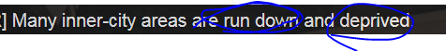 run -down areas = very poor/impoverished













// concrete jungle











## Arguing a point

|  |
| --- |
|  |
|  |
| Notice how the speaker in the previous video argues his point. After stating the topic of his presentation – **crime, vandalism and anti-social behavior** – the speaker asks some rhetorical questions to get the listener thinking. |
|  |
| But what are the root causes of these social problems? |
|  |
| Is it just that some people are bad, and some are good? |
|  |
| Or do the causes go deeper than that, to how our society treats its people? |
|  |
| After that he states his own position on the subject. |
|  |
| Basically, the three main causes of crime are: poverty, family environment and living conditions. |
| After stating his position, he argues his point by giving details of his beliefs. |
|  |
| Poverty, to a greater or lesser extent, is often a cause of crime. |
|  |
| Your family, their social and financial position and how they bring you up, also has a huge influence. |
|  |
| But the third major factor and the one that’s often neglected is: living conditions. |
|  |
| He then introduces a related point. |
|  |
| In urban areas nowadays, we seem to live on top of each other rather than beside each other. Many inner-city areas are run-down and deprived. |

|  |
| --- |
| One can also argue a point by quoting research. |
|  |
| Research shows that people in run-down areas begin to disrespect their environment and disrespect each other. |
|  |
| Another effective technique is to present an alternative view before refuting it. |
|  |
| Of course, causes of crime are not simplistic, they are inter-connected and deep-rooted. However, the way people behave in their environment has a lot to do with how their environment behaves towards them. |

## Reading) Impact of big-box stores opening on your community

Read this letter to a local politician, which was written in response to the newspaper article 'More **Big-Box Stores** to be Built in our Area'. //Big-box store 规模很大的商店 V.S. mom-and-pop store小型的(商店,生意)

Dear Councilor Riera,

***[leading sentence, express my opinion first]*** I am writing to you to express my concerns about more **big-box stores** being built in our area. I really think that it will destroy our community and change our way of living together.

***[ pros ]***

**Proponents  /prəˈpəʊnənt/** (supporters) of **big-box stores** argue that these stores improve the lives of many citizens. **Big-box stores** provide consumers with convenient, **one-stop shopping** 一站式购物at low prices and apparently **boost** the local economy by **revitalizing low-income neighborhoods**.

***[ cons (more cons than pros, that’s why I’m against it) ]***

However, it is common knowledge that **big-box stores** practice substandard labor practices (85% of their employees are being paid minimum wage and have no social or health benefits) and that they cause existing, smaller businesses to **go bankrupt/bust**. //**[ 首要支持者 the leading proponent, advocator**

**Furthermore**, **I’d like to point out/It’s my contention that/I think that** the impact these **big-box stores** have on our environment. There will be a lot more traffic, congestion, pollution and overdependence on cars and **freeways高速公路**. And have you thought about people who do not have a car or cannot drive to the big superstores? What will happen to them?

***[ conclusion ]***

**I want to reiterate that** the arrival of more **big-box stores** in our area will change our lives **drastically** and I am not sure that it will be for the better.

Yours sincerely,

Ms. Margaret Hallas

Group the items according to whether they are a pro or con.

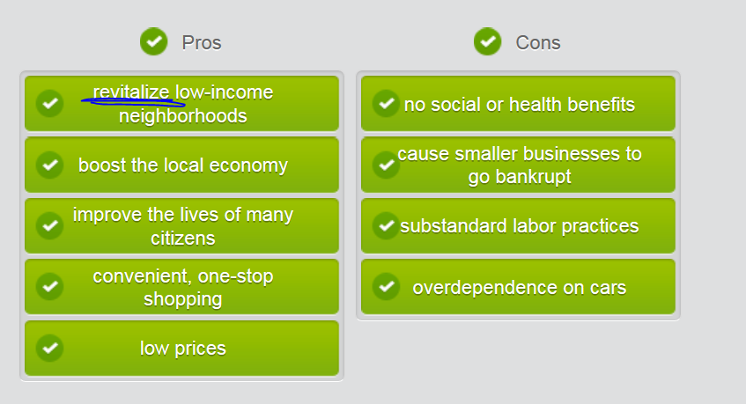

## 3rd row) Emphasizing a point of view

|  |  |  |
| --- | --- | --- |
| **Reiterating a point of view** | |  |
|  | |  |
| Use expressions like the following to reiterate a point of view. | | |
|  | |  |
| ***I must stress again*** *my opposition to more big-box stores.* |  |  |
|  | |  |
| ***I'd like to point out again*** *that a superstore will boost the local economy.* |  |  |
|  | |  |
| ***I want to repeat my assertion*** *that superstores cause an overdependence on cars.* |  |  |
|  | |  |
| ***I repeat*** *that convenient, one-stop shopping benefits everyone.* |  |  |
|  | |  |
| ***I want to reiterate*** *that minimum wage jobs don't help workers.* |  |  |

## How to express your opinions in **idiomatic expression (地道的表达)**

|  |  |
| --- | --- |
| add your opinion to a conversation | * I think/I’d like to point that/It’s my contention that ( contention: a strong opinion) * That's my honest opinion. * 总的来说(我觉得xx) For what it's worth (FWIW), xxxx e.g. For what it's worth (FWIW) 总的来说(我觉得xxx), modern art is quite valuable.  e.g. FWIW, Mage Armor is quite powerful, but it's a trade off. 总的来说(我觉得xxx)，法师护甲确实很强力，但这是一种交易  E.G. For what it's worth (FWIW), the sculptures will probably be vandalized.   // for what it is worth; an abbreviation used in emails, to say that you are not sure if what you are writing is very useful 不论有没有用〔电子邮件中的缩写，表示不确定正在写的东西是否很有用〕   * That's my two cents (我的一点意见/想法). have few opinion or suggestions.  e.g. Here comes my two cents. Can we change the patent title a little bit?  E.g. I'm sorry for lag. I'm damned busy in crazy APIc killer tasks. Well, I have two cents about your issue. Please check my Red comments. Thank you.  e.g**. If you want my two cents**, public art is an expression of the public itself. |
| **Agreeing with sb.** | * **I'm with you (on this point).** I’m with Vivian on this issue. * I totally agree with you * **You have a point.** * **I was just thinking that myself. 我也正那么想呢** * I cannot agree with you any more * **Tell me about it! Too many compromises**. |
| **disagreeing with** | * Sorry that I’m not with you (on this point). Instead, I’ve got to **side with VV.** * Sorry Jill, but I have to **side with Vivian on that.** * **I’m in my two minds我有两种想法. On one hand xxx, on the other hand.** * Let's just drop it, shall we? * **That's not always the case但事实并非总是如此.** * **Can't see it, myself. 我可不认为** * I’ve gone right off you. = doesn’t agree with sb in a humorous way * **除非我死了（表示强烈反对）Over my dead body.** e.g. You wanna get married with that gangster? My opinion? **Over my dead body**! |
| Use expressions like these to end a heated discussion where people are becoming frustrated or upset. | * 让我们接受彼此的不同观点吧 Let's agree **to** disagree. / Let's agree to disagree on that. * Be careful; **whatever you say** can convey annoyance or a patronizing attitude. |
|  |  |

## How to emphasize your points

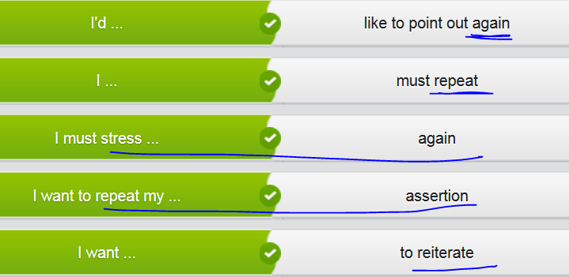

e.g.

**I want to reiterate** my support for the idea.

**I must stress again that** it will boost the economy.

**I want to repeat my assertion that** it doesn't help.

**I'd like to point out again that** it benefits everyone.

## 4th row) Writing

Write a few paragraphs about **big-box stores, e.g. WarMart**. What effect do you think they have on communities? e.g. YuHuZhai, a new developing/burgeoning community. Do they bring more **[prəuz] and cons/kɒn/**   **(benefits or drawbacks/downsides)** with them?

// **Big-box store 规模很大的商店 V.S. mom-and-pop store小型的(商店,生意)**

## Sample

***[ leading sentence: tell your opinion firstly ]***

There are **definitely/easily/undoubtedly/unquestionably** **pros and cons** (**benefits and drawbacks/downsides**) associated with **big-box superstores**, but I think we’ve got to be realistic about the circumstances of some communities.

***[ cons ]*** I understand the argument that big-box superstores create primarily low-wage jobs with substandard labor practices and provide few if any social or health benefits to those same workers. I also understand that these giant superstores could possibly bankrupt smaller stores (brick-and-mortar stores) that are unable to compete with them. I think just about everyone knows this to be true.

***[ pros (more than cons), that’s why I’m the proponent ]* On the other hand/However,** if a community is already in economic trouble, with few jobs available and people struggling to feed their families, saying ‘no’ to a giant superstore doesn’t seem to make any sense at all. Isn’t a low-way job better than no job at all? **Furthermore**, if a community is also suffering from poverty/impoverishment, wouldn’t the lower prices that a big-box superstore can offer hep those most in need?

**I want to reiterate that** I understand the big-box superstores are not the perfectly **viable**/**feasible** answer for every community. Different communities have their unique characters in specific circumstances and different demands. All **I’d like to point out is that**, under certain circumstances, a big-box store might do more good than harms for a struggling community.

## Mine writing

***[ leading sentence: tell your opinion firstly ]*** Building big-box stores will **unquestionably** bring pros and cons in our community. Based on the circumstances in our community that is a new emerging community, I am sort of a proponent **/prəˈpəʊnənt/** (supporters) for welcoming big-box stores, which easily will bring enormous job opportunities and boost the local economy.

***[ Cons ]*** Firstly, I’ve got to acknowledge that big-box superstores will definitely have negativeimpact on our environment. There will be a lot more traffic noise, congestion, and pollution. Additionally, opponents also claim that giant store just provide substandard labor practices with low salary or very few social or health benefits. However, compared with unemployment or sluggish economy, is the low salary really a big matter? From my perspective, boosting economy, propelling employment rates, and stimulating investments in our community are the top issues. Per this point, the big-box stores will easily bring tons of taxes and diverse source of income for the local government.

***[ Pros (more than cons), so that’s why I’m the proponent ]***

**Undoubtedly, big-box stores** can improve the lives of many citizens in our community by providing consumers with convenient, **one-stop shopping**. Especially, compared with prices in mom-and-pop groceries, giant superstores can provide competitively low prices which obviously is more taste to most local people.

**In a nutshell, I want to reiterate that** I understand the big-box superstores might be not the perfect, **viable** answer for every community. All **I’d like to point out is that**, under the circumstances of our community that is a relatively not rich area, a big-box store might bring more benefits than drawbacks.

# ** CNN related news about making a speech, e.g.

e.g. Indian , a sprawling city

e.g. **Firecrackers** and fireworks are just one **contributing factor** to pollution in Xi’an, which lacks an effective public transportation system. The **sprawling city 一个胡乱扩张的城市** has 9 million vehicles, and new **license plate numbers 车牌号**are being registered at a rate of 1,400 per day. Consumption of **fossil fuels**, like coal and natural gas, that are **non-renewable energies**, “contribute” a lot to **carbon footprint** that is the main reason to our climate change and air pollution. Additionally, construction dusts add poisonous particles and toxic gasses to the mix. The Friday's ruling is not the first time the court has enforced action on pollution. In 2015, the court **levied a new tax on征兵，征税** commercial trucks entering the city -- a **draconian** (harsh and severe) measure that environmentalists viewed as a positive.

## Stop: Indian: the yoga holy site in world

For better or worse, the holy city of Rish, which rests on the **foothills**丘陵地带 of the **Himalayas** [,himə'leiəz] in northern India, will always be associated with the Beatles and their **sojourn** /ˈsɒdʒɜːn/在外逗留 to study transcendental **meditation**冥想 in 1968. Although Rish is the self-styled "yoga capital of the world," In addition to being a melting pot of worldly intellectuals, the **Hindu** **pilgrimage** site that rests peacefully on both sides of the **sacred** Ganges river has recently become a hub for outdoor activities.   
//retreat 撤退；休息寓所 //珠穆朗玛峰 Mount Everest: the peak of the Himalayas

Experience **ashram['æʃrəm] 修行 life:** Rish boasts one of the world's largest **clusters of ashrams['æʃrəm]**修行的处所, loosely defined as **spiritual retreats**. The process of **bunking** on site begins with a 5 a.m. call to **mediation** followed by a sunrise yoga class, and ends with more yoga, chanting, lectures and group meals.

The more **authentic** ashrams, like Niketan -- host to [the International Yoga Festival](http://www.internationalyogafestival.org/) -- offer basic shared rooms without internet for as little as $12. Heating and hot water can be inconsistent, which is worth **bearing in mind** 把…记在心里. **Ashrams** tend to be either yoga-centric, like the massive [Siva ashram](http://www.sivanandaonline.org/public_html/), or geared more to **mediation** like Dham. The more **upscale** [hotel](http://www.yogniketan.in/) provides luxurious river views and a spa **at a premium**. Most ashrams allow **drop-ins/dropper-in不速之客**, something ideal for those who value satellite TV, Wi-Fi and room service from the comfort of nearby accommodation, like [Hotel](http://www.hotelyogvashishth.com/) [Niketan](http://www.yogniketan.in/).

Take part in a Ganges ceremony: Aartis, a Hindu religious **ritual (religious ceremony)**, are performed on river banks every night at sunset, and involve music and fire as offerings to the Ganges, known as the "mother" in Hindu culture. It is not uncommon to see bonfires blazing in the distance, signaling a body being **cremated** with ashes soon to be scattered into the river -- a Hindu **ritual** that promises to free the soul from the constant **cycle of rebirth**. //使转世：reincarnate [,riːɪn'kɑːneɪt], reincarnation

Dipping your feet in the Ganges while setting a flower bed **afloat** is part of the tradition -- as is full bathing, for those who want a more authentic experience. The river runs rapidly, however, and the banks can be slippery with **moss**, so do exercise caution. **Be wary/cautious of** faked holy men looking to **fleece you**诈骗 for a "donation," however. Rish is home to a number of small temples which act as **makeshift venues** for musicians previously. **Technically** it's the former **ashram**, who famously taught transcendental **meditation** to celebrities [sɪ'lebrɪtɪ] that included Mia. But it was the Beatles who put these cities on the map when they visited his **sprawling** 14-acre ashram in 1968.

The compound was left discarded after that celebrity / **sɪ'lebrɪtɪ** /moved to Europe in 1970s. Although the Indian government has done little to restore it, it was opened to the public in 2015. Foreigners like to **gripe/complain**抱怨, 肠绞痛 that they are charged nearly $9 for entry, while Indians pay $2. Inside, you can walk into the domed mediation caves that inspired "Dear Prudence", and visit the great **meditation** hall **festooned[fɛ'stʊn] [建] 以花彩装饰 with** colorful **graffiti [grə'fiːtɪ]/doodles涂鸦**. //graffiti V.S. giraffe[dʒə'rɑ:f]

Only a 90-minute drive away, the National Park is home to more than 500 elephants, along with scattered **panthers**, **leopards**, **deer** and even **anteaters**, and offers on-site accommodation for those who want to take in more than a day's worth. Rish is surrounded by hiking trails, some challenging and others that **weave into** short hikes to temples which provide **stunning**极美的 views into town. Guided **treks** that range between four and 16 days to the **Himalayas**[ˌhɪməˈleɪəz] can be booked by the [Red Chilli adventure company.](http://www.redchilliadventure.com/)

(Extreme sports) **White water rafting** has become **increasingly** popular and can be booked for half or full-day **excursions /ɪkˈskɜːʃən/ 短途旅行** down the Ganges, taking in up to 36 km of glorious/**stunning** scenery along the way. For even more adventure try [**bungee-jumping**](http://www.jumpingheights.com/) from a cliff off the Ganges.

Giant footbridges: A more **pedestrian** [pɪˈdestrɪən] form of outdoor activity -- but one that can be just as **treacherous** -- involves crossing Rishi's two narrow suspension footbridges. Built in 1929, Jhula rises 59 feet above water level, stretches 450 long, spans 750 feet, and is just six feet wide. Though it is mainly used for foot traffic, **pedestrians** crossing the bridge -- which shakes **noticeably** -- must maneuver around **honking** motorcycles and bicyclists, as well the odd cows or family of monkeys swinging from the cables. **//horn V.S. honk 按汽车喇叭 V.S. horny**

Visit Rishi Town: Many **pilgrims** to Rishi bypass this **microcosm ['maikrəukɔzəm] 微观世界；小宇宙** of India, unaware that a **bustling** street market exists just minutes from their quiet confines. Rishi town is a **maddening** cluster of restaurants, sweet **boutiques**, fruit stands. Sampling the specialty sweets as well as the fresh peanut **brittle/cracker** is highly recommended. **//brittle, like cracker, a crispy biscuit //clutter V.S. cluster**

Socialize at the cafes: As a **holy** city, Rishi strictly forbids alcohol and non-vegetarian food, so dining out is a pretty **sober** affair. For instance, doesn't offer meat bread, but does serve **terrific**/fabulous coffee alongside tasty desserts and food items. Many travelers tend to **hang out** in these cafes for a lot longer than a meal, since Wi-Fi is free and **relatively相对来说** stable. **This can be a fun way to exchange stories with other travelers, link to their Instagram accounts, and keep track of their journeys**. (e.g. wheni’m in Seoul)

As in most parts of India, many different animals coexist with humans around town, including sheep, cows, pigs and dogs. Monkeys are **notorious** for grabbing food off people as they walk by, or **raiding** hotel rooms if they spot open windows. Though it's best to avoid the monkeys, feeding the peaceful dogs any leftovers is a cause worthy of stirring up some good **karma**因果报应，因缘.